Functional Understanding Document

For

“Record Manager”

Prepared on

Jul 17, 2013
te

Revision History
Version No | Prepared By | Reviewed By | Approved By
1.0 | Ramesh Bhaabu

Review Details
Version No | Change Description | Date of Release | Remarks

Table Of Contents

Introduction
Record manager used to contain the information related to the records. Record manager used to create, edit and delete the folder, insert, document, e-folder and e-document.
Record manager contains the following options:
- Record Home Page
- Quick Search
- Intake
- Model
- Check In
- Check Out
- Request
- Pending Request
- Status Check
- Waitlist
- Transfer to Box
- Inventory Label Printing
- Reports
- Utilities
- Administration
- Setups

Record Home Page
Record Home Page provides the following
- A Get-In-Find-Go query: It used to find the record by using the details given in Get, In, Find boxes. The result of this query will return the record in grid view or in tree view.
- A statistical analysis of record processing: The Records Home Page summarizes the volume of work performed by a user, group, timekeeper or office. The statistics can be customized for a particular user, group of users, timekeepers or offices, and can display information for a specified date range.
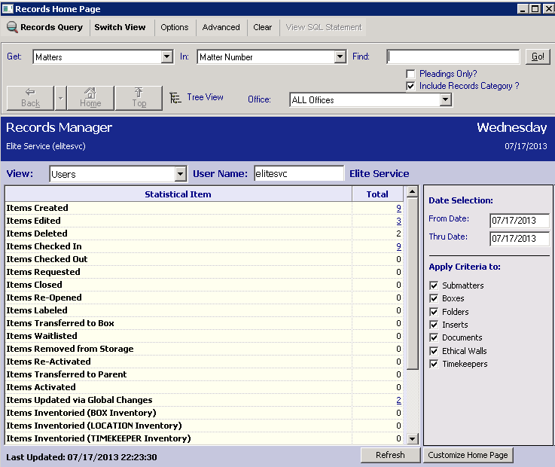

- Switch View: It used to switch between the tree view and grid view.
- Options: It used to customize the query option, grid option and tree option.
- Advanced: It used to find the record with advanced search query.
- Clear: It used to clear the details entered in the input fields.
- View SQL Statement: It enables users to see the SQL statement generated by Records Manager when processing their request.
- Pending only: If this check box is selected, then only the pending files will display. If it not selected, then all file type will display.
- Office: It used to select the particular office for which we want the result.
- Home Button: It used to return record home page.
- Top Button: It used to return the previous results after a drill down.
- Back Button: It used to return the previous Grid View, Tree View or the Records Home Page. The down arrow button will displays the list of previous query results to quickly return to that listing.
- Refresh Button: It used to refresh the statistics displayed.
- Customize Home Page Button: It used to customize the displayed statistical items.

